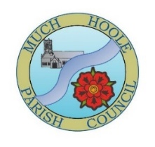 | Minutes of Much Hoole Parish Council meeting held on Monday 10th June 2026 at 7.30pm at The Venue at Hoole Village Memorial Hall, Liverpool Old Road, PR4 5QA.

Present: Cllrs K. Hayes (Chair), R. Lea, E. Jackson, E. Houghton, P. Cocker, and Acting Clerk Mr P. Cafferkey.
- Apologies for Absence
Cllrs A. Taylor, T. Hewitt and P. Fox

- Declaration of Interest and Dispensations
Cllr E. Houghton declared a non-pecuniary interest in agenda item 7.

- Minutes of the previous Meeting
It was resolved that the minutes of the MHPC meeting held on 11th May 2026 were agreed to be a true and accurate record. Proposed by Cllr E. Houghton, seconded by Cllr R. Lea and agreed unanimously. The Chair signed the minutes.

- Public Time
No members of the public were present.

- Correspondence from members of the public.
Three items were received from members of the public.
Item 1: Correspondence concerning overgrown Public Rights of Way (PRoW) in the Haunders Lane and River Douglas area. It was agreed that Cllr P. Cocker would plan a schedule of work with the Lengthsman to try clear the PRoWs. It was acknowledged that this would be a sizeable task and may not be achievable by the Parish Council alone, given its budgetary limitations, and the fact that this task is primarily the responsibility of Lancashire County Council.
Item 2: A member of the public has been in contact stating that she would like the Parish Council to arrange that the bus stop on Liverpool Old Road that is to be replaced by a new one on 18th June be moved to a new location. As the Highways Authority of LCC are responsible for granting permission to relocate a bus stop the Clerk would advise the resident accordingly.
Item 3: A member of public has raised concerns regarding the hedgerow overgrowth where Brook Lane meets Liverpool Old Road restricting the width of the pavement making it necessary to walk in the road at this junction which can be dangerous. This matter has been reported by Cllr P. Cocker via the Love Clean Streets app and a response is awaited. This will be monitored.

- Village Hall
In the absence of Cllr A. Taylor, Cllr R. Lea provided a brief update. The Village Hall continues to be enormously successful and financially viable. An outcome by SRBC on planning permission regarding the proposed Padel Courts is thought to be imminent. A new stone plaque celebrating the opening of the new Village Hall has now been installed.
- Off Road Cycle Track
- Cllr R. Lea reported that an inspection had been undertaken, no problems identified other than the usual litter. The Track is well used.
- The new “No E bike Use” sign has been erected. Also, a wooden paneled wall has been erected to prevent cycle track users from crossing over the fence into the neighbouring field and a barrier has been installed at the entrance to prevent cyclists coming straight out of the pump track on to the road at speed.
- Reports from other meetings and information on future events
Cllr R. Lea confirmed he had attended the SRBC Western Parishes Forum, although poorly attended there had been very good demonstrations on CPR (Cardiopulmonary Resuscitation) and the use of defibrillators. Cllr Lea had also attended a SRBC Community Action Network meeting and three potential sources of funding had been presented, subject to a suitable project; these are Progress Housing, The Duchy of Lancaster Benevolent Fund, and The National Lottery Community Fund. Cllr E. Houghton reported that she would be attending an online meeting of the LALC Executive on the 11th June 2026.
- Finance
- It was resolved to sign off the Bank reconciliation for the month of May 2026, signed by Cllr E Houghton and unanimously agreed.
- The Council noted the Clerk’s financial statement as at 31 May 2026.
- It was resolved to authorise the following payments, proposed by Cllr E. Houghton, seconded by Cllr R. Lea and unanimously agreed:
- Annual Governance and Accountability Return (AGAR) 2025/26
- Receipt of Internal Audit Report for year ended 31 March 2026. The Council noted the positive report.
- To review and approve the effectiveness of the system of internal control. It was resolved to approve the Parish Council’s documented system of internal control. Proposed by Cllr K. Hayes, seconded by Cllr P. Cocker and agreed unanimously.
- To consider and approve the Annual Governance Statement (Section 1). It was resolved to approve the Parish Council’s Annual Governance Statement (Section 1). Proposed by Cllr K. Hayes, seconded by Cllr P. Cocker and agreed unanimously.
- To consider and approve the Accounting Statements (Section 2). It was resolved to approve the Parish Council’s Annual Governance Statement (Section 2). Proposed by Cllr K. Hayes, seconded by Cllr P. Cocker and agreed unanimously.
- To note the dates for the exercise of public rights. The Council noted the dates as starting on Friday 29th June 2026 and ending on Friday 7th August 2026.
- Grants
A grant application had been received from 1st Hoole Scout Group for £1275.00 for 3 x 4-man tents and 3 x 2-man tents. It was resolved that the grant application for the sum of £1275.00 be approved. Proposed by Cllr E. Houghton, seconded by Cllr P. Cocker, and agreed unanimously.
- Footpaths and Gardens
- Much Hoole footpaths 11, 12, 23 & 22 inspected this month. 11 & 12 all clear, 23 all clear and has a new gate fitted to enter the fields, 22 has a new gate fitted and a new Tread Board to replace the old broken bridge. Unfortunately, the remaining three stiles are in very poor condition and have been reported to the LCC PROW Team and an acknowledgement has been received ref PRW-161802.
- FP11 The S147 Form was completed by the Landowner and forwarded to the LCC PROW Team. This will now be dealt with by the Legal team at LCC with a view to providing the new metal gate to be sited at Moss House Lane end.
- FP26 and FP27 actions are deferred until the next meeting.
- The Clerk agreed to contact SRBC to ascertain when the park equipment will be cleaned and repainted.
- Cllr P. Cocker has reported the damaged bench on Brook Lane / A59 via Love Clean Streets. Depending on the outcome, the purchase of a new bench by the Parish Council may be proposed but this would be subject to a future agenda item.
- Replacement Bus Shelter
The installation date is confirmed as 18th June 2026. Cllr P. Cocker has liaised with residents to ensure that the highway is kept clear for the installation. Cllr R Lea volunteered to be there on the day and to put out traffic cones to keep the installation area clear.
- Newsletter
Suggestions for the content for the annual newsletter to be issued in September were proposed by Cllr R. Lea and reviewed and agreed by the Council. Cllr Lea also proposed content and a layout for the Business Directory and this was reviewed and agreed. Cllr Lea will obtain a price for printing the newsletter and business directory to be proposed at the July meeting.
- Newsletter
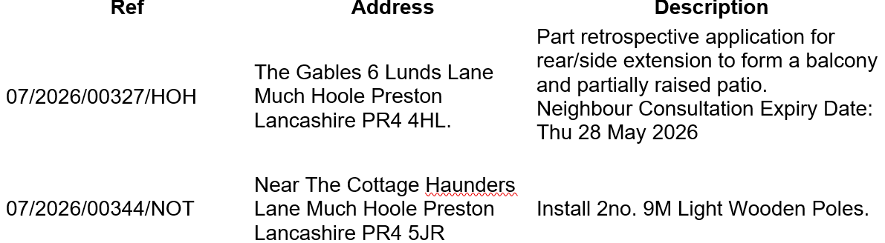
There were no objections to the above planning items.
- Items for next agenda
To consider purchase of bench for corner of Brook Lane / A59 depending on outcome of LCCs response to Love Clean Streets App submission.
- Date of next meeting
The Council unanimously agreed the date of the July Meeting as 7.30pm on Wednesday 8th July 2026 at ‘The Venue’, Liverpool Old Road, Much Hoole. The meeting closed at 20:50.

